Routing
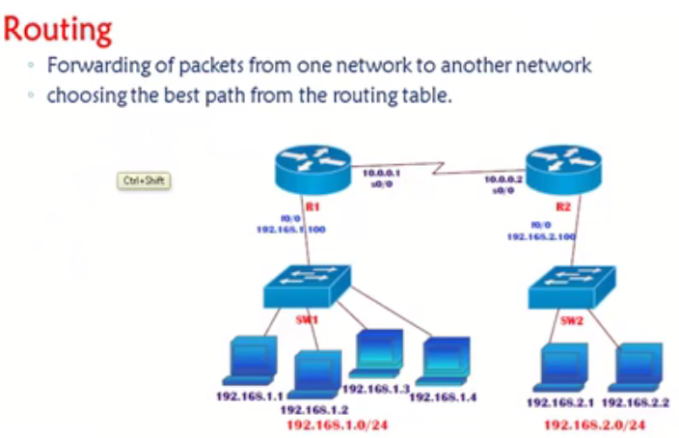
Even though all the devices are connected , Lins are UP and IP address are given still we cannot communicate between 192.168.1. network to 2. Network , Hence we need routing .
Three Types of routing .
Static ,
Default ,
Dynamic .

Difference between Static and Dynamic is , In static administrator will be deciding the best route in dynamic routing protocols will automatically decide the best route .
Default routing generally used in internet connections .
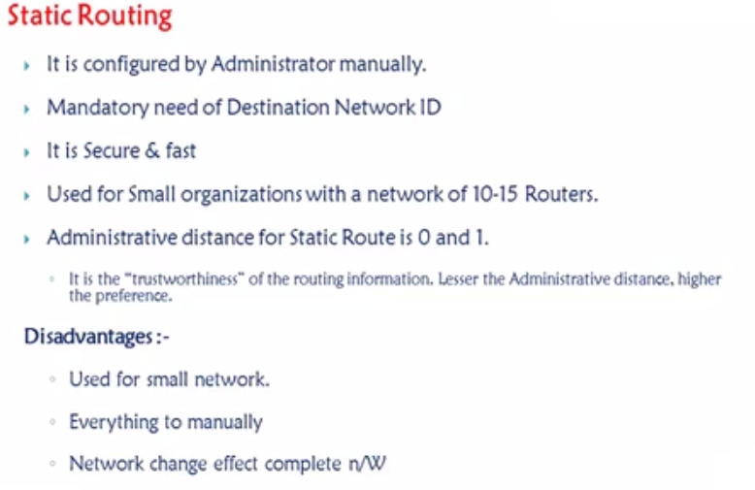
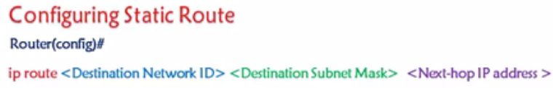
Lab :

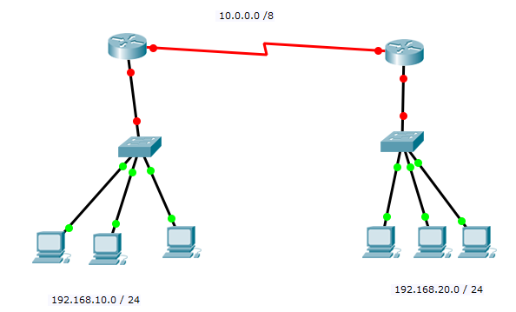
Show IP Route , Ping , Traceroute .
Lab Task : 3 Routers .

Default Routing

Default route which is also known as the gateway of last resort, is used in forwarding packets whose destination address does not match any route in the routing table .

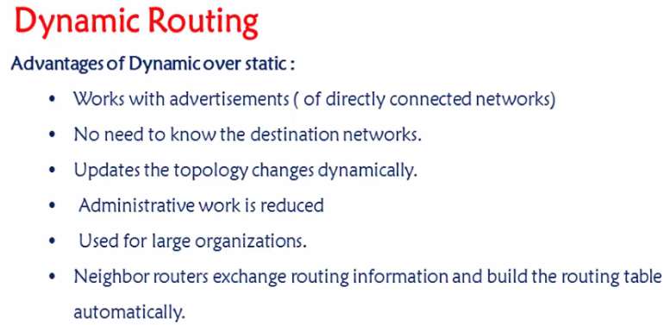

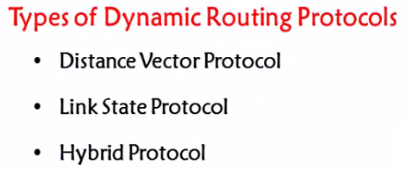
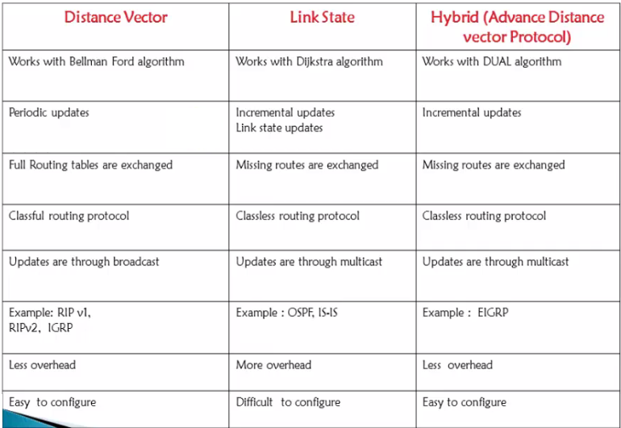

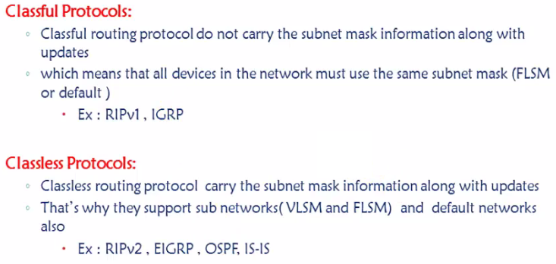
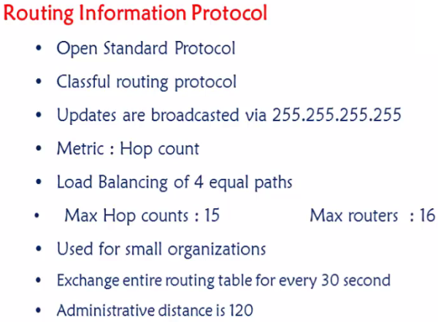

RIP TIMERS

UPDATE timer = 30Sec. Every router will share its complete routing table with its neighbors once in 30 sec .
INVALID timer = 180 [30+150] , 31st sec – If any link goes down none of the Update will be shared to any of its neighbors as they will wait till 180 sec hoping it will come up again .
FLUSH timer = 60sec more 240 sec , [180+60] – Removal of entry from Routing table .
HOLDDOWN timer = 180sec – In general whenever there is a new update , It will wait for 180 sec for the best route calculation .

In RIP Convergence time is 240sec .
EIGRP = 15sec
OSPF = 40sec
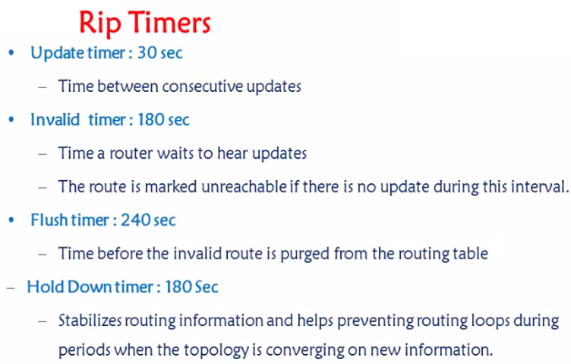
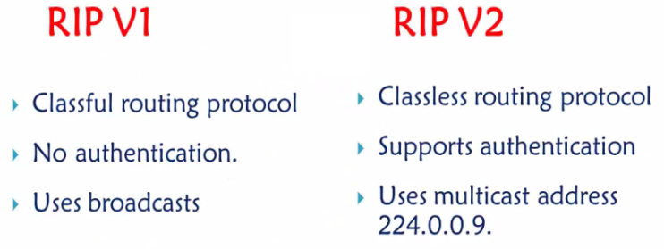
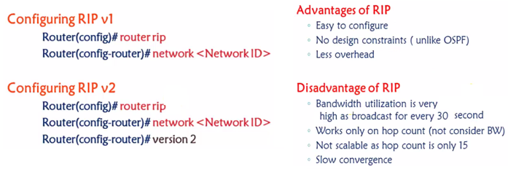
Problem with RIP (Slow Coverage time, Routing loop, Count to Infinity and DV Algorithm)

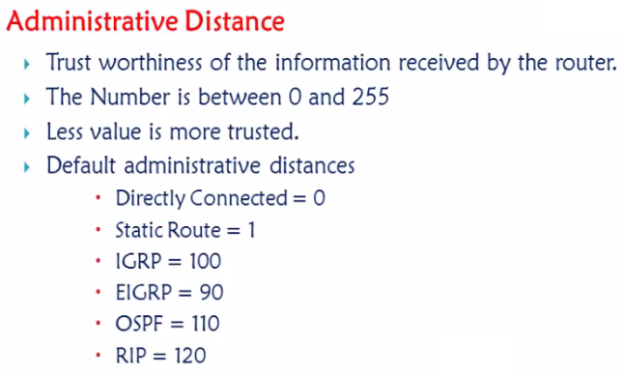
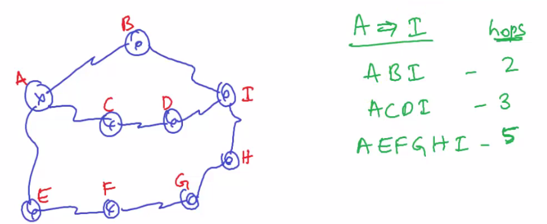
ABI – 100Mbps – EIGRP , ACDI – 80Mbps – RIP , AEFGHI – 10Mbps - Static.
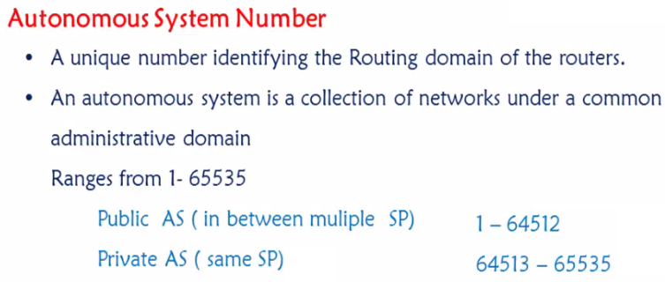
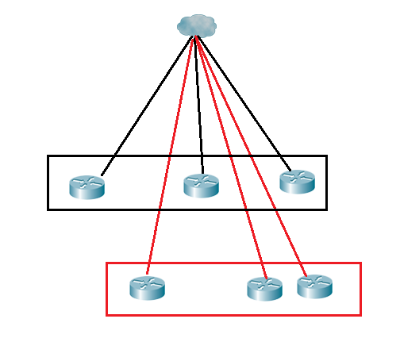
How the SP will differentiate the traffic coming from ABC company and XYZ company – Through Autonomous System number . NOTE : Circuit ID is different .
Private AS system number , Airtel and TATA both can use same AS numbers, no issue as it is used within the SP so no issues . Public AS are used to connect between two different SP .
Similar to public and Private IP address .
Once we now what is Autonomous system number – there are two protocol categories – IBGP and EBGP .
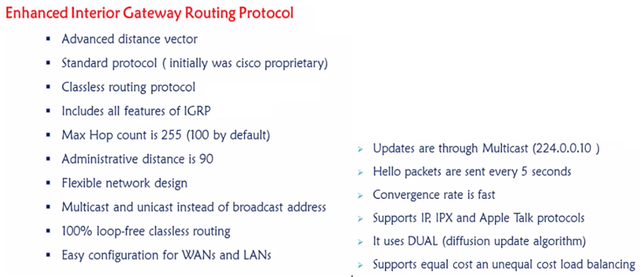

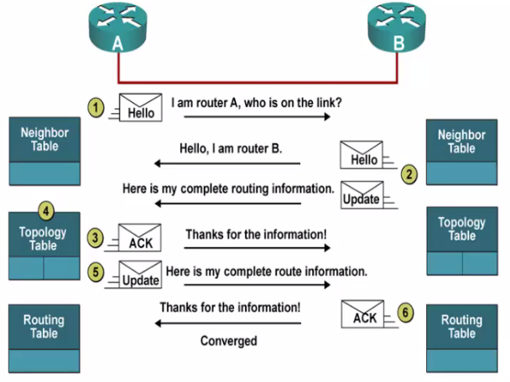
Hello all I am running EIGRP is there anyone else who is running the same and it will send multicast 224.0.0.10 , All EIGRP listen at this address . If any router is not running EIGRP they will not get these hello msgs neither they will understand .
Topology table will have a list of all best routes , This is when it will run DUAL algorithm and find out the best routes .
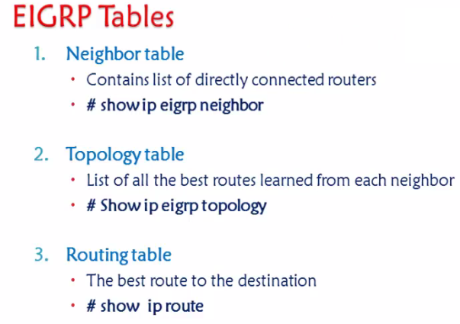
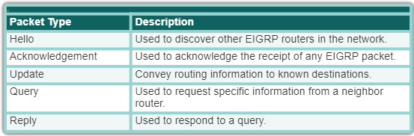

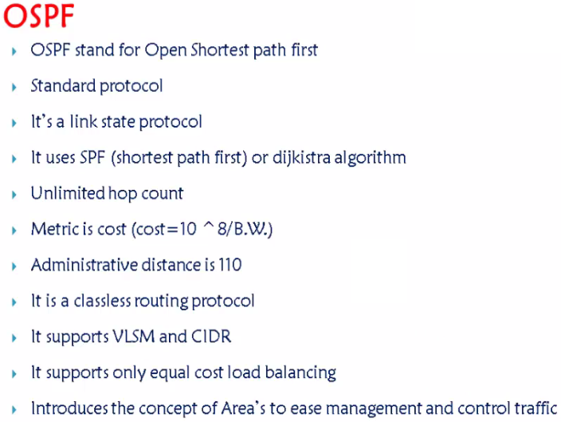
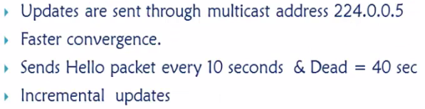
The OSPF timers on a Cisco router depend on what time of interface they are used on.

By default the timers on a broadcast network which include Ethernet, point-to-point and point-to-multipoint are 10 seconds hello and 40 seconds dead. The timers on a non-broadcast network are 30 seconds hello 120 seconds dead.
Incremental updates meaning - Updates will be sent only if there is a change
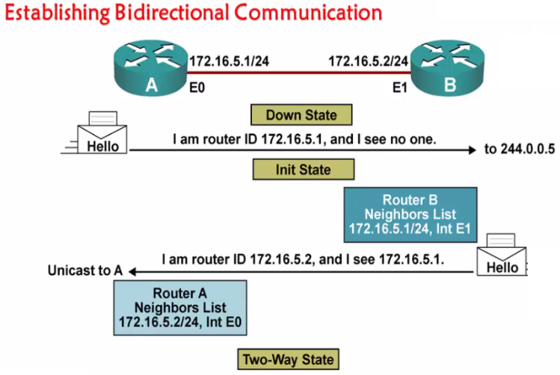
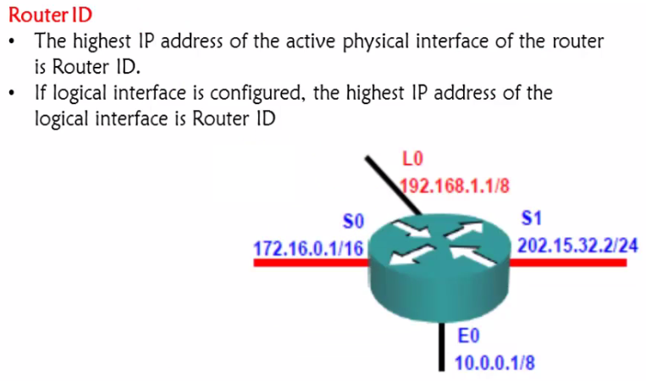
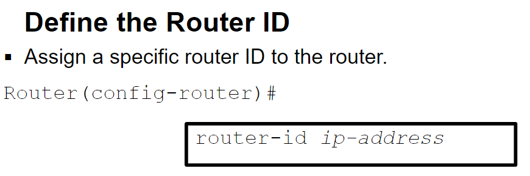
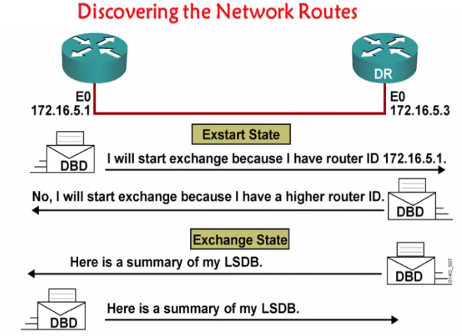

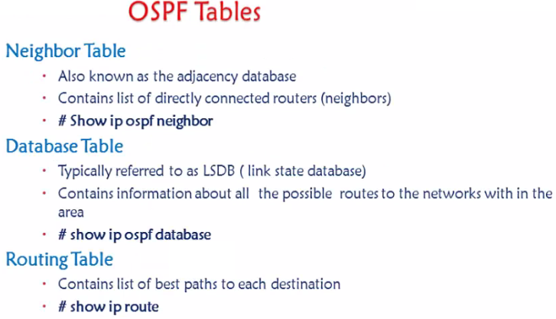
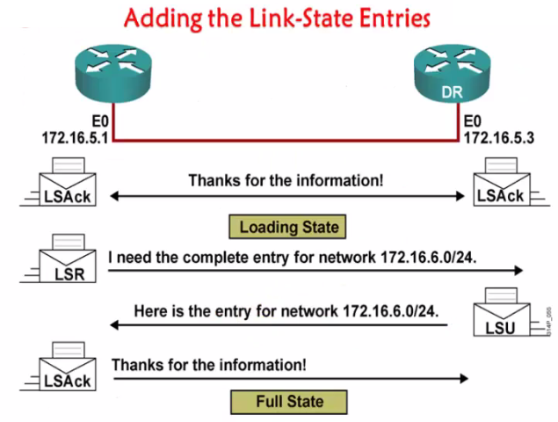
- The hello packet
- The Database Description Packet : ...
- The Link State Request packet : ...
- The Link State Update packets: ...
- The Link State Acknowledge packets

